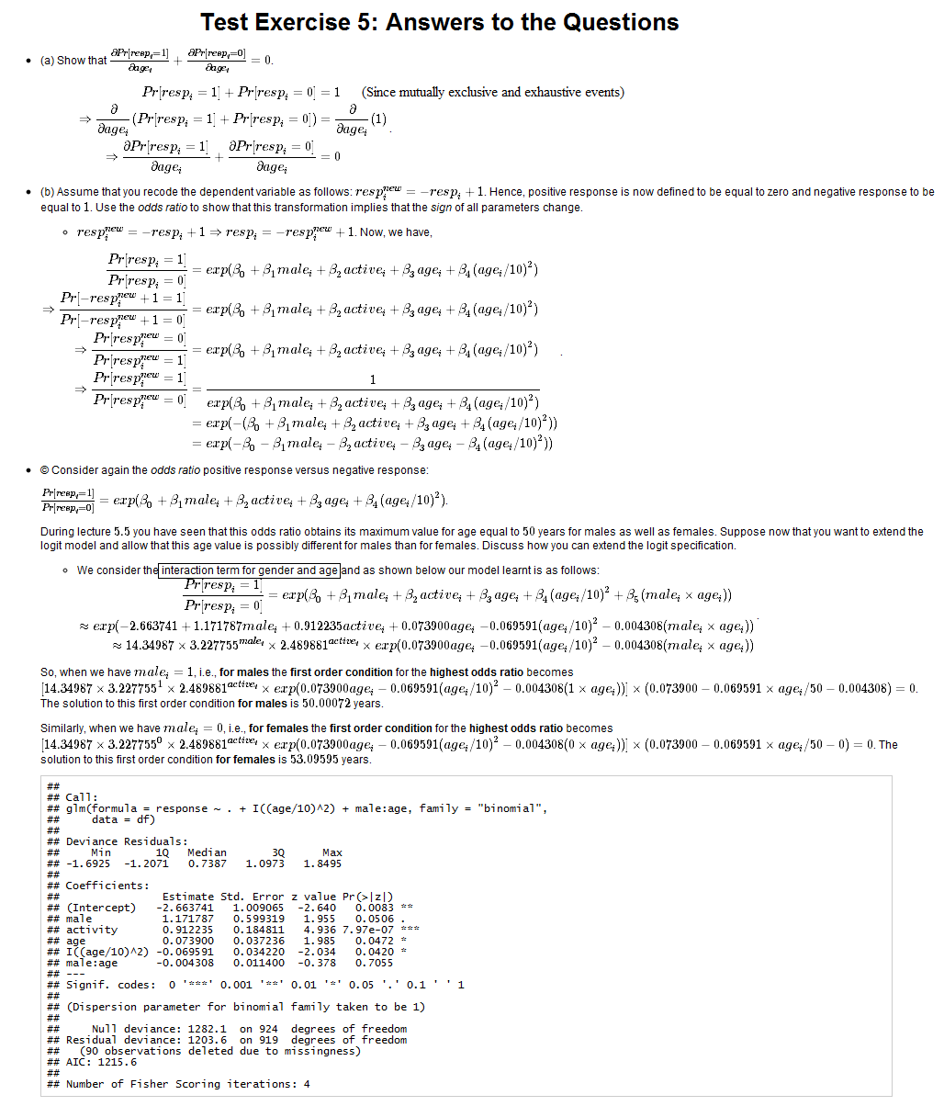

(respi is a binary variable, can have only 2 values 0 & 1)